**Assignment#06-PF-Thoery**

**Attempt all questions. Submission deadline is 02-May-2020.**

**Question#01**

Write a program that initializes a string in string arrays and computes its length in terms of characters without using built-in-functionS

**SOURCE CODE**

#include <iostream>

using namespace std;

int main()

{

char string[50];

int i, length = 0;

cout<<"Enter a string \n"<<endl;

cin>>string;

for (i = 0; string[i] != '\0'; i++)

{

length++;

}

cout<<"\nThe length of the string "<<string<<" is "<<length<<endl;

}

**OUTPUT**

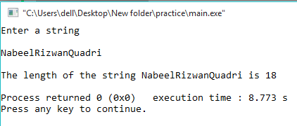

**Question#02**

**Write a program that takes a string input in character arrays in upper case and transforms the string into uppercase without using built-in-function.**

**SOURCE CODE**

#include<iostream>

using namespace std;

int main()

{

string str;

cout<<"Enter a string to be converted into opposite case "<<endl;

cin>>str;

// Calling the Function

//convertOpposite(str);

int ln = str.length();

// Conversion according to ASCII values

for (int i=0; i<ln; i++)

{

if (str[i]>='a' && str[i]<='z')

//Convert lowercase to uppercase

str[i] = str[i] - 32;

else if(str[i]>='A' && str[i]<='Z')

//Convert uppercase to lowercase

str[i] = str[i] + 32;

}

cout << str;

return 0;

}

**OUTPUT**

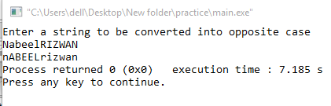

**Question#03**

Write a program that takes 6 strings input by user (country names) and concatenate the string “country” with each of the input string and print the concatenated string. In addition, also find the length of each concatenated string and print. (Note: You can use built-in-function)

**SOURCE CODE**

#include<iostream>

#include <string.h>

using namespace std;

int main()

{

char country1[20], country2[20], country3[20], country4[20], country5[20], country6[20], country[20]=" country";

cout<<"Enter 1st country name"<<endl;

cin>>country1;

cout<<"Enter 2nd country name"<<endl;

cin>>country2;

cout<<"Enter 3rd country name"<<endl;

cin>>country3;

cout<<"Enter 4th country name"<<endl;

cin>>country4;

cout<<"Enter 5th country name"<<endl;

cin>>country5;

cout<<"Enter 6th country name"<<endl;

cin>>country6;

cout<<strcat(country1, country)<<endl;

cout<<"Lenght of the sring is "<<strlen(country1)<<endl;

cout<<strcat(country2, country)<<endl;

cout<<"Lenght of the sring is "<<strlen(country2)<<endl;

cout<<strcat(country3, country)<<endl;

cout<<"Lenght of the sring is "<<strlen(country3)<<endl;

cout<<strcat(country4, country)<<endl;

cout<<"Lenght of the sring is "<<strlen(country4)<<endl;

cout<<strcat(country5, country)<<endl;

cout<<"Lenght of the sring is "<<strlen(country5)<<endl;

cout<<strcat(country6, country)<<endl;

cout<<"Lenght of the sring is "<<strlen(country6)<<endl;

return 0;

}

**OUTPUT**

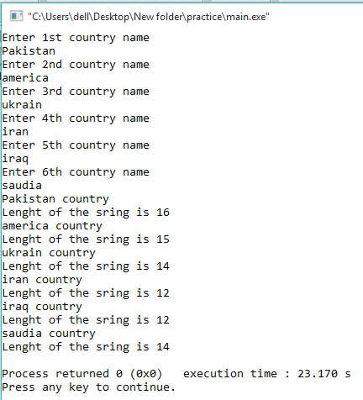

**Question#04**

Write a program that by defining a function even_odd(), to test whether a given integer is even or odd. Pass an integer value as an argument to a function. The UDF function test whether a given integer is even or odd and prints the corresponding message.

**SOURCE CODE**

#include<iostream>

using namespace std;

void evenodd (int a)

{

if(a%2==0)

cout<<"The number is even"<<endl;

else

cout<<"The number is odd"<<endl;

}

int main()

{

int number;

cout<<"Enter a number: "<<endl;

cin>>number;

evenodd (number);

return 0;

}

**OUTPUT**

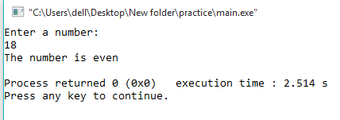

**Question#05**

Write a program which defines a UDF table(). This UDF takes an input from user in its body and prints the table of that number.

**SOURCE CODE**

#include<iostream>

using namespace std;

void evenodd (int a)

{

for(int i=0; i<=12; i++)

{

cout<<i<<" * "<<a<<" = "<<i*a<<endl;

}

}

int main()

{

int number;

cout<<"Enter a number: "<<endl;

cin>>number;

evenodd (number);

return 0;

}

**OUTPUT**

